**List of assets I worked on in group project:**

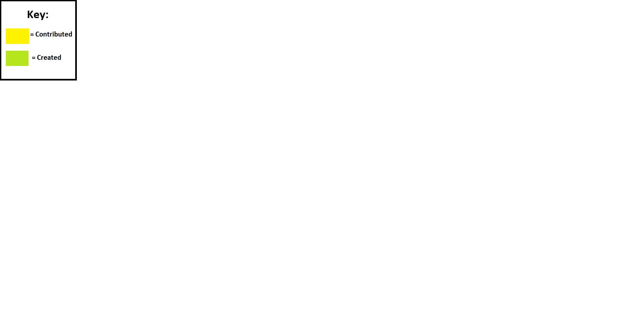Note: The materials and levels that mention the material files and the .Unity levels are not included in the contribution folder system but are in the final compiled project folder.

3D Models:

animalPen_01

animalPen_gate_01

BarnWindow_01

barrel_01

cardboardBox_01

chickenCoop_01

CompostBin_01

crate_01

cupboard_01

factory_controlPanel_01

factory_tank_01

factory_wallLight_01

fenceWall_01

filingcabinet_01

hay_01

industrialBarrel_01

Ladder_01

locker_01

meat_01

modular_conveyorbelt_01

modularpipes_01

PlantPots_01

produceBin_01

Shed_01

shippingContainer_01

storage_rack_01

toolbox_01

wheat_fields_01

wooden_palette_01

WoodenChest_01

WoodenContainer_01

WoodenPalette_01

WoodenPost_01

Materials:

MetalCasing Material

Animal Icon Material

Hay Material

Wheat_Fields Material

Levels:

DEMO LEVEL (Contributed)

LEVEL_HARD (Created and Contributed)

Level_Medium (Created and Contributed)

Main_Menu (Contributed)

TUTORIAL LEVEL (Contributed)

UI Assets:

level select tutorial bubble

detectionBubble_confusion_01 Material

detectionBubble_detected_01 Material

detectionBubble_detected_01.png

detectionBubble_confusion_01.png

Animal Help Icon_Enemies.png

Animal Help Icon_HidingSpots.png

Animal Help Icon_Interaction.png

Animal Help Icon_Lose_tip.png

Animal Help Icon_Movement.png

Animal Help Icon_PressurePlates.png

Animal Help Icon_Context.png

Animal Icon.png

EasySelectionImage.png

HardSelectionImage.png

MediumSelectionImage.png

TutorialSelectionImage.png

Lose Screen Mockup.png

Win Screen Mockup.png

**Theory Based Contributions:**

**Documents:**

**Research and Moodboards:**

Research into the demographic and audience of group project concepts.docx

The Exiles Group Project Initial Research - Jamie Gostling.docx

Moodboard 1 Setting - Farm.png

Moodboard 2 Setting - Barn.png

Moodboard 3 Setting - Factory.png

**Level Design:**

Alpha Paper Prototype.jpg

Level Selection Sketches.jpg

Level Design Sketch #1.jpg

Level Design Sketch #2.jpg

**Concept Sketches:**

Game Concept ideas.jpg

Game asset ideas.jpg

**Meeting Minutes:**

Meeting Minutes Week 2 – Discord.docx

Meeting Minutes Week 6.docx

**Playtesting & Feedback:**

Beta Playtest Feedback Session 1.docx

Beta Playtesting Feedback form #1 (Dan).docx

Beta Playtesting Feedback form #2.docx

{Template} Beta Playtesting Feedback: (Katy).docx

Road to Beta Roadmap of development: The Exiles.docx